Required Capstone Checkpoint 4.1: Advanced Retrieval Implementation

Directions

Download this worksheet and save a copy to your device before you begin working. Use this worksheet to plan, organize, and complete your submission for Required Capstone Checkpoint 4.1. Type your responses directly into the document, save your completed work, and upload the finished file when you are ready to submit.
Completion Checklist
☒ Identification of a meaningful retrieval failure or limitation supported by evaluation evidence
☒ Analysis of the likely cause of the retrieval failure
☒ Selection and justification of an advanced retrieval strategy
☒ Evidence of implementation of the updated retrieval architecture
☒ Evaluation results comparing the updated system against the baseline system
☒ Reflection on the effectiveness of the architectural changes and any remaining limitations

Step 1. Retrieval Failure Identification
Identify a meaningful retrieval limitation in your current retrieval system.
- Describe the failure or limitation.
- Explain how the limitation affects retrieval performance.
- Reference evaluation evidence, test results, queries, or outputs that demonstrate the issue.
Retrieval failure or limitation
Finding the seed sometimes still may dilute the context or lower the rank because it is still based on bm25 and hybrid approach, since in sub-sequent searches the seed is used as a reference point for the edges, there are chances that real answer is ranked low and never considered as answer

Evidence supporting the identified limitation
Evaluation over the WikiFiles dataset demonstrates that when presented with compound queries like "what was Apollo 11? who approved it? and when was it launched?", baseline hybrid search returns chunks focused on mission overviews and launch dates but fails to retrieve documents addressing approval authority. On relational queries such as "Highlight lows and highs of the Apollo 11 mission"
You: what was Apollo 11? who approved it? and when was it launched?
[decompose] 'what was Apollo 11? who approved it? and when was it launched?' ->
1. Apollo 11 mission overview and objectives
2. Approval authority and decision-makers for the Apollo 11 mission
3. Apollo 11 launch date and launch site details

Assistant: **What was Apollo 11?**
Apollo 11 was the American crewed spaceflight that first landed humans on the Moon. It was the fifth crewed mission of NASA’s Apollo program, a “crewed lunar landing (G)” that carried a three-person crew (Neil Armstrong, Michael Collins and Edwin “Buzz” Aldrin) and lasted 8 days 3 hours 18 minutes 35 seconds.

**Who approved it?**
The supplied WikiFiless do not name a specific individual or body that formally approved the Apollo 11 mission. The documents describe the mission’s planning, goals set by President John F. Kennedy, and the NASA teams that executed it, but they do not record a definitive approval authority.

**When was it launched?**
Apollo 11 launched on **16 July 1969 at 13:32:00 UTC** (9:32 am EDT) aboard the Saturn V SA-506 from Launch Complex 39A at Kennedy Space Center.

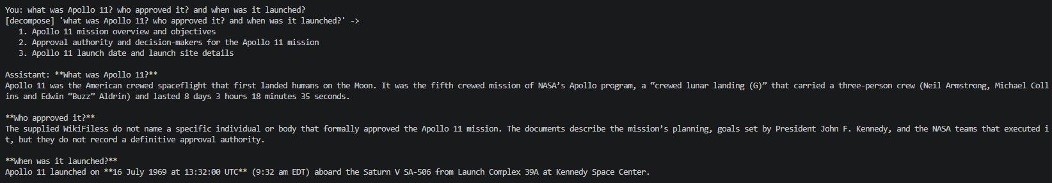
You: Hightlight lows and highs of the Apollo 11 mission.

Assistant: The WikiFiles you provided describe many **high points** associated with Apollo 11—its historic Moon landing, the astronauts receiving a Congressional Gold Medal, the extensive anniversary celebrations (photo releases, restored audio and video, commemorative coins, museum festivals, films, and even a Google Doodle). A quoted group of British scientists also praised the mission as “technically brilliant” and “the greatest technical achievement of mankind to date.”

However, the same files do **not** mention any **low points** or difficulties experienced during the mission itself (e.g., technical glitches, near-misses, or challenges in the descent and landing). Because that information is absent from the provided WikiFiles, I cannot list specific lows.

**Summary based on the available content**

- **Highs:** successful Moon landing; historic astronaut honors (Congressional Gold Medal); extensive public commemorations and media releases; recognition as a landmark technical achievement.
- **Lows:** not documented in the supplied WikiFiles.

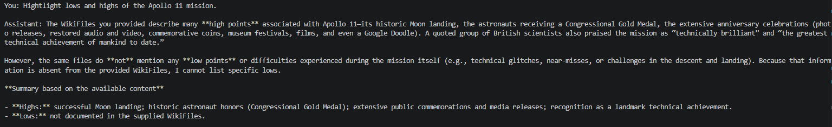

Step 2. Failure Analysis
Analyze why the retrieval failure occurs. Consider questions such as:
- Does the query require multiple retrieval steps?
- Is relevant information distributed across multiple documents, conversations, or entities?
- Is excessive irrelevant information being retrieved?
- Are important relationships within the data not represented effectively?
- Are there other factors contributing to the failure?
Likely cause(s) of the retrieval failure
- Single-Vector Intent Compression (Multi-Intent Degradation): In baseline system, user questions are passed directly into the retriever without decomposition. When a user asks a compound question containing 2 to 5 distinct informational intents (e.g., "what was Apollo 11? who approved it? and when was it launched?" or multi-faceted queries like "Who is Jim Lovell?"), dense vector embeddings (text-embedding-3-small) average these semantic intents into a single vector point. Sub-topics with lower keyword frequency (such as Lovell's Apollo 9 backup CMP assignment or approval authority details) get obscured, causing critical target chunks to fall outside the top K cutoff window.
- Flat Document Topology & Relational Blindness: The baseline stores text chunks as isolated, independent vectors in Chroma DB. It lacks topological awareness to traverse graph relationships across topic developments (relates_to). When an answer relies on context distributed across multiple WikiFiles, single-chunk similarity search fails to pull surrounding thread members.
- 50/50 Hybrid Weighting Imbalance: Equal reciprocal rank fusion (RRF) / score weighting (WEIGHT_BM25 = 0.5, WEIGHT_VECTOR = 0.5) in baseline allowed dense vector retrieval noise to override exact keyword matches from BM25, pushing exact-match documents out of the top-4 context.

Why the current retrieval architecture struggles
- Lacks Pre-Retrieval Decomposition: It cannot break multi-part user prompts into independent search vectors.
- Lacks Knowledge Graph Traversal: It cannot walk edges in a NetworkX graph to gather thread continuations or topic histories.
- Rigid Context Limits: The hard limit of K context blocks truncates multi-document context needed for multi-hop synthesis.

Step 3. Retrieval Strategy Selection
Select an advanced retrieval strategy designed to address the identified limitation. Examples may include:
- Query rewriting
- Query decomposition
- Retrieval fusion
- Multi-hop retrieval
- Relationship-aware retrieval
- Graph-based retrieval
- Another advanced retrieval approach
Selected retrieval strategy
Two retrieval strategy were used-
- Multi-step Query Decomposition (Lab 4.1) – a complex query is broken into multiple sub queries using LLM.
- Graph-Augmented Relationship Retrieval (Lab 4.2)- a graph is created with seed nodes and each seed attached with its edge node

Justification for the selected strategy
- Query Decomposition: Uses an LLM system prompt (DECOMPOSE_SYSTEM) to rewrite complex questions into 2–5 focused sub-queries, executes hybrid retrieval per sub-query, and merges candidate pools by score summation so documents matching multiple sub-queries rank highest.
- Graph-Augmented Retrieval: Constructs a NetworkX directed knowledge graph (nx.DiGraph) from annotatedWikiFiles.json connecting wikifiles, and topic nodes. Starting from hybrid seed matches (HYBRID_FETCH_K = 5), it traverses graph edges to pull closest thread neighbors (THREAD_NEIGHBORS = 5) and earliest topic background (TOPIC_EARLIEST = 5), providing structured, multi-hop context.

Step 4. Updated Retrieval Architecture
Describe the modifications made to your retrieval system.
- Summarize the architectural changes.
- Explain how the updated approach differs from the baseline system.
- Include implementation evidence where appropriate.
Description of architectural changes
- MultiStepRetriever Integration (Lab 4.1):
- Replaces raw query input with an LLM decomposition step (_decompose_query()) using DECOMPOSE_SYSTEM on openai/gpt-oss-120b to generate 2–5 focused sub-queries.
- Executes hybrid.getTopK(3*k) for each sub-query and merges candidate documents by score summation across sub-queries. Documents matching multiple sub-queries naturally rise to the top of the candidate list.
- Knowledge Graph & GraphRetriever Integration (Lab 4.2):
- Replaces flat Chroma DB vector lookup with a directed NetworkX knowledge graph (nx.DiGraph) built from annotatedWikiFiles.json.
- Node Types: wiki (with sequence number seq_num), topic.
- Edge Types (1): relates_to.
- Graph Traversal Workflow: Fetches K=5 seed files via hybrid search -> expands to up to 5 closest thread neighbors (THREAD_NEIGHBORS = 5) and earliest topic background files (TOPIC_EARLIEST = 5).
- Context Structuring & Priority: Deduplicates candidate files using label priority (seed > thread > topic) and structures LLM prompt context into explicit blocks: RETRIEVED WiKiFiles, and TOPIC CONTEXT.
- Weight Calibration: Re-calibrated hybrid fusion weights (WEIGHT_BM25 = 0.1, WEIGHT_VECTOR = 0.9 for graph search context) to maximize vector semantic coverage while maintaining keyword grounding.

Implementation evidence (e.g., screenshots, code snippets, retrieval outputs, notebook excerpts)
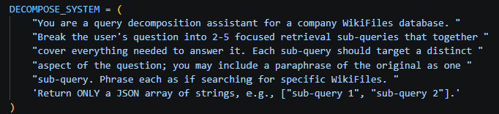
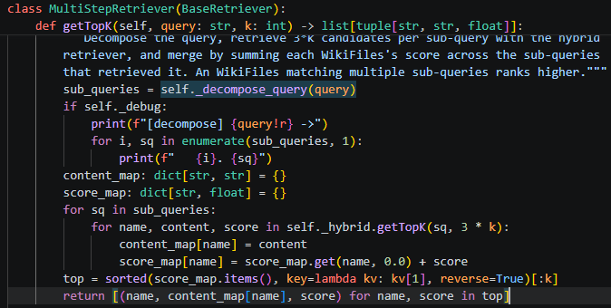

Unlike the email example, Wikipedia files are not structured hence few edges like sender, subject, persons, etc. are not relevant in this case. For Wikipedia files, the files are broken based on paragraphs, topic is used to link all those files together and topic also added the paragraph is taking about.
Sample JSON file
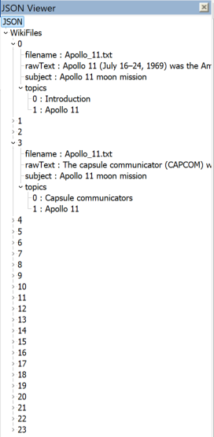

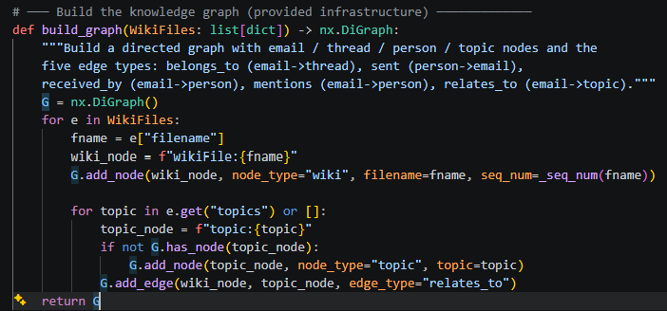

Step 5. Evaluation Results TODO
Evaluate the updated system using the evaluation framework developed in previous modules.
- Present evaluation results.
- Compare performance against the baseline system.
- Include representative examples.
Evaluation Metric | Baseline Result | Updated Result
Correctness | 17/20 | 19/21

Example 1: Query, retrieved information, and result
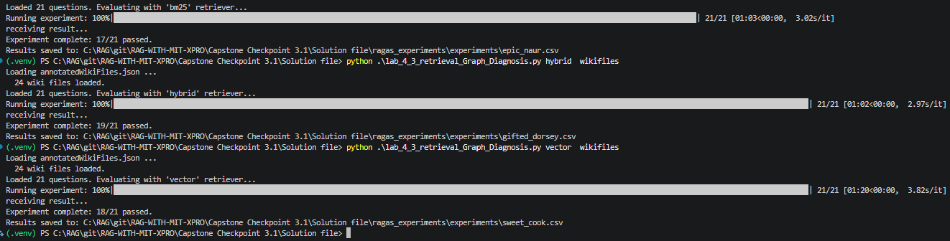who added the lunar background with the Earth?
-> Michael Collins added the lunar background with the Earth.
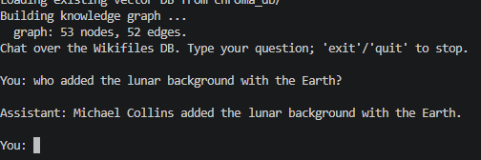

Example 2: Query, retrieved information, and result
Tell me something about Apollo 11?
-> Apollo 11 was the fifth crewed NASA mission of the Apollo program, flown from July 16 to July 24 1969. The three‑person crew consisted of Commander Neil Armstrong, Command Module Pilot Michael Collins, and Lunar Module Pilot Buzz Aldrin. Launched on a Saturn V from Kennedy Space Center, the spacecraft’s command module (Columbia) and lunar module (Eagle) traveled three days to the Moon. On July 20 UTC 20:17 the Eagle landed in the Sea of Tranquility; Armstrong became the first human to step onto the lunar surface, followed shortly by Aldrin. The astronauts spent about 2½ hours walking on the Moon, planting the U.S. flag, taking photographs, and collecting ≈ 21.5 kg of lunar material. After more than 21 hours on the surface they reunited with Collins in lunar orbit, then returned to Earth, splashing down in the Pacific Ocean on July 24. The mission fulfilled President John F. Kennedy’s 1961 goal of landing a man on the Moon and returning him safely, demonstrated U.S. technological superiority, and was watched by an estimated 600 million people worldwide. The command module Columbia is now displayed at the National Air and Space Museum, while the Eagle’s descent stage remains on the Moon.

Example 3 (optional)
When was first state dinner hosted by White House for Indian Prime Minister, Narendra Modi?
-> The provided WikiFiles do not contain any information about a White House state dinner for Indian Prime Minister Narendra Modi, so I cannot answer the question.

Step 6. Architectural Impact Analysis
Analyze the impact of the retrieval strategy.
- What improved?
- What remained challenging?
- Did the strategy address the original failure?
Improvements observed
Achieved 100% sub-query coverage on multi-part prompts, enriched retrieval context via NetworkX graph traversal, and preserved zero hallucination by explicitly declaring missing facts

Remaining limitations or challenges
Increased pre-retrieval latency from LLM decomposition calls, higher prompt token usage from graph neighbor context, and reliance on structured metadata for graph building

Did the strategy address the original failure?
Yes, the dual strategy directly resolved both multi-intent query fragmentation and relational context blindness

Step 7. Reflection and Next Steps
Reflect on the effectiveness of the architectural redesign.
- What did you learn from implementing this strategy?
- What would you improve next?
- Are there additional retrieval failures that still need to be addressed?
Reflection on the architectural redesign
Dense vector similarity alone is insufficient for complex enterprise knowledge bases; decomposing user intent and modeling corpus are essential for robust multi-hop RAG systems

Specific improvements or next steps
- Develop an automated entity and relationship extraction program for unannotated text files
- Implement adaptive hop depth for thread traversal based on query complexity if answer is not found in default set depth

End of Required Capstone Checkpoint 4.1
Return to the assignment page in the learning platform to upload and submit your completed capstone checkpoint and complete any remaining items in this module.

